LAB PROGRAMS

NAME: M.SAI HARSHITHA
REG.NO: 192424408
COURSE CODE: DSA0502
COURSE NAME: QUERY PROCESSING FOR DATASCIENCE

5.Write a Pandas program to create a bar plot of the trading volume of Alphabet Inc. stock between two specific dates.
Aim:
To write a Pandas program to create a bar plot of the trading volume of Alphabet Inc. stock between two specific dates.
Algorithm:
- Import the Pandas and Matplotlib libraries.
- Create a DataFrame containing stock trading volume data.
- Save the DataFrame as a CSV file.
- Read the CSV file.
- Convert the Date column into datetime format.
- Select records between two specific dates.
- Create and display a bar plot of the trading volume.
Code:
import pandas as pd
import matplotlib.pyplot as plt
stock = pd.DataFrame({
"Date": ["2024-01-01", "2024-01-02", "2024-01-03", "2024-01-04", "2024-01-05"],
"Volume": [1200000, 1500000, 1300000, 1700000, 1600000]})
stock.to_csv("alphabet_stock.csv", index=False)

df = pd.read_csv("alphabet_stock.csv")
df["Date"] = pd.to_datetime(df["Date"])
filtered_data = df[(df["Date"] >= "2024-01-02") & (df["Date"] <= "2024-01-05")]
print("Trading Volume Between Two Specific Dates:")
print(filtered_data)
plt.figure(figsize=(8,5))
plt.bar(filtered_data["Date"].dt.strftime("%Y-%m-%d"), filtered_data["Volume"])
plt.title("Trading Volume of Alphabet Inc.")
plt.xlabel("Date")
plt.ylabel("Trading Volume")
plt.grid(True)
plt.show()
Output:
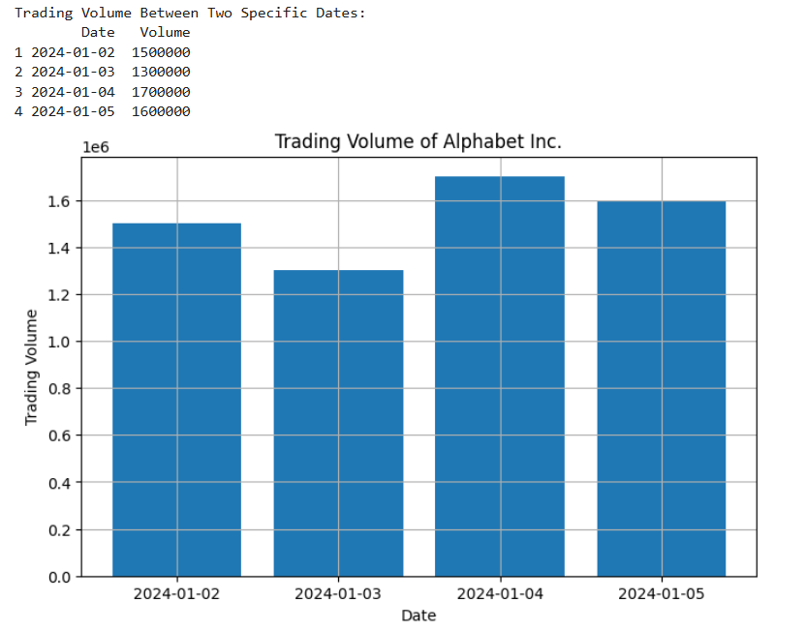

6.Write a Pandas program to create a line plot of the historical stock prices of Alphabet Inc. between two specific dates.
Aim:
To write a Pandas program to create a scatter plot of the trading volume and stock prices of Alphabet Inc. stock between two specific dates.
Algorithm:
- Import the Pandas and Matplotlib libraries.
- Create a DataFrame containing Date, Stock Price, and Trading Volume.
- Save the DataFrame as a CSV file.
- Read the CSV file.
- Convert the Date column into datetime format.
- Select records between two specific dates.
- Create and display a scatter plot of Stock Price versus Trading Volume.

Code:
import pandas as pd
import matplotlib.pyplot as plt
stock = pd.DataFrame({
"Date": ["2024-01-01", "2024-01-02", "2024-01-03", "2024-01-04", "2024-01-05"],
"Close": [140, 145, 143, 148, 150],
"Volume": [1200000, 1500000, 1300000, 1700000, 1600000]
})
stock.to_csv("alphabet_stock.csv", index=False)
df = pd.read_csv("alphabet_stock.csv")
df["Date"] = pd.to_datetime(df["Date"])
filtered_data = df[(df["Date"] >= "2024-01-02") &
(df["Date"] <= "2024-01-05")]

print("Stock Data Between Two Specific Dates:")
print(filtered_data)
plt.figure(figsize=(8,5))
plt.scatter(filtered_data["Close"],
filtered_data["Volume"])
plt.title("Alphabet Inc. Stock Price vs Trading Volume")
plt.xlabel("Stock Price")
plt.ylabel("Trading Volume")
plt.grid(True)
plt.show()

Output:
